


LAB WEEK 5
  - SEP 2026 SEMESTER

‘AFFAN NAJIY BIN RUSDI
22010453
BACHELOR OF COMPUTER SCIENCE
MODELING AND SIMULATION
TEB2103

Contents
Activity 3
Spread of Disease 3
Traffic Collision Simulation 5
Bank Queue 7
Ant Food Collection 9
Museum Visitor Simulation 13
Airport Shopping Simulator 17
Airport Shopping Simulator with Money 20

Activity

Spread of Disease
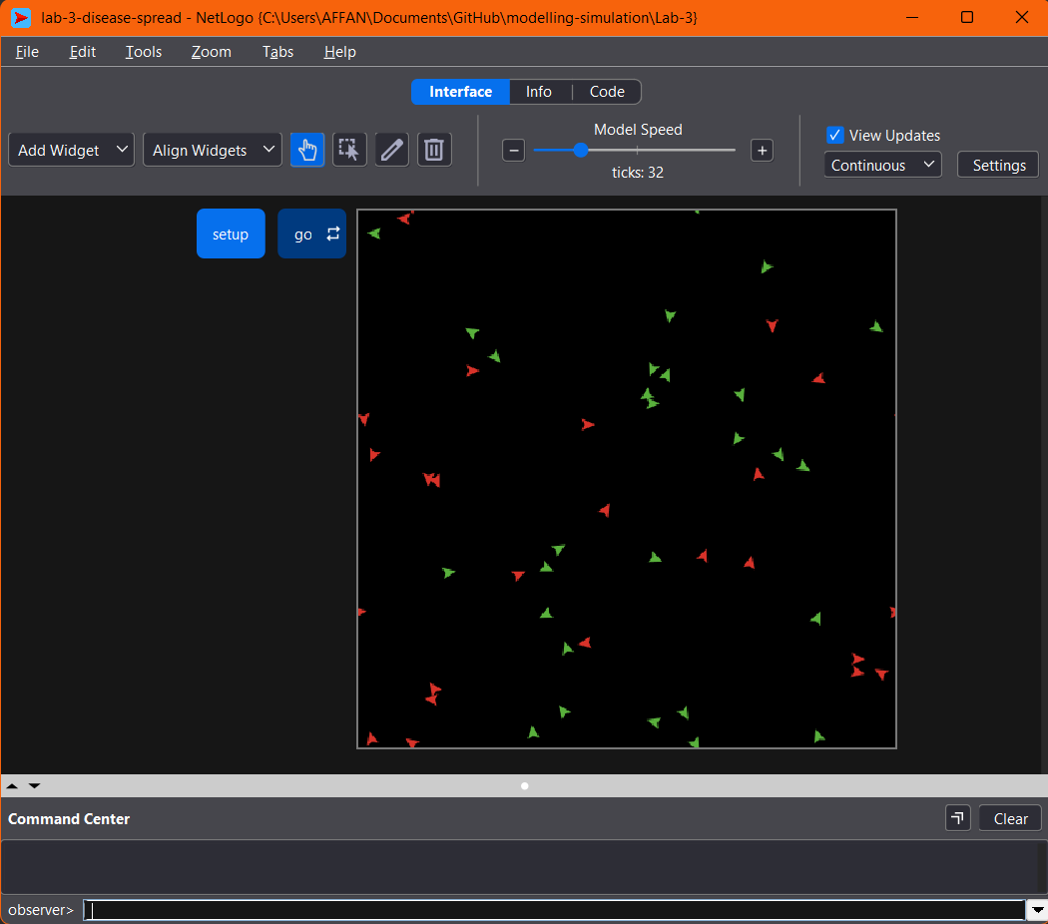

Explanation
Firstly, 50 turtles were created, where one random turtle is infected (red) and the rest are healthy (green). Every tick, each turtle wanders by turning a random angle and moving one step. Then, every infected turtle infects healthy turtles within 1 patch using in-radius, which selects agents within a given distance. As a result, the infection spreads slowly, speeds up, and levels off, taking the total number of ticks to infect everyone. This is similar to a flu spreading in a crowded lecture hall.
Code
turtles-own [infected?]

to setup
clear-all
create-turtles 50 [
setxy random-xcor random-ycor
set infected? false
set color green
]
ask one-of turtles [
set infected? true
set color red
]
reset-ticks
end

to go
;; stop once everyone is infected
if all? turtles [infected?] [ stop ]

ask turtles [
rt random 30
lt random 30
fd 1
]

;; infected people infect anyone within 1 patch
ask turtles with [infected?] [
ask other turtles in-radius 1 [
if not infected? [
set infected? true
set color red
]
]
]
tick
end

Traffic Collision Simulation
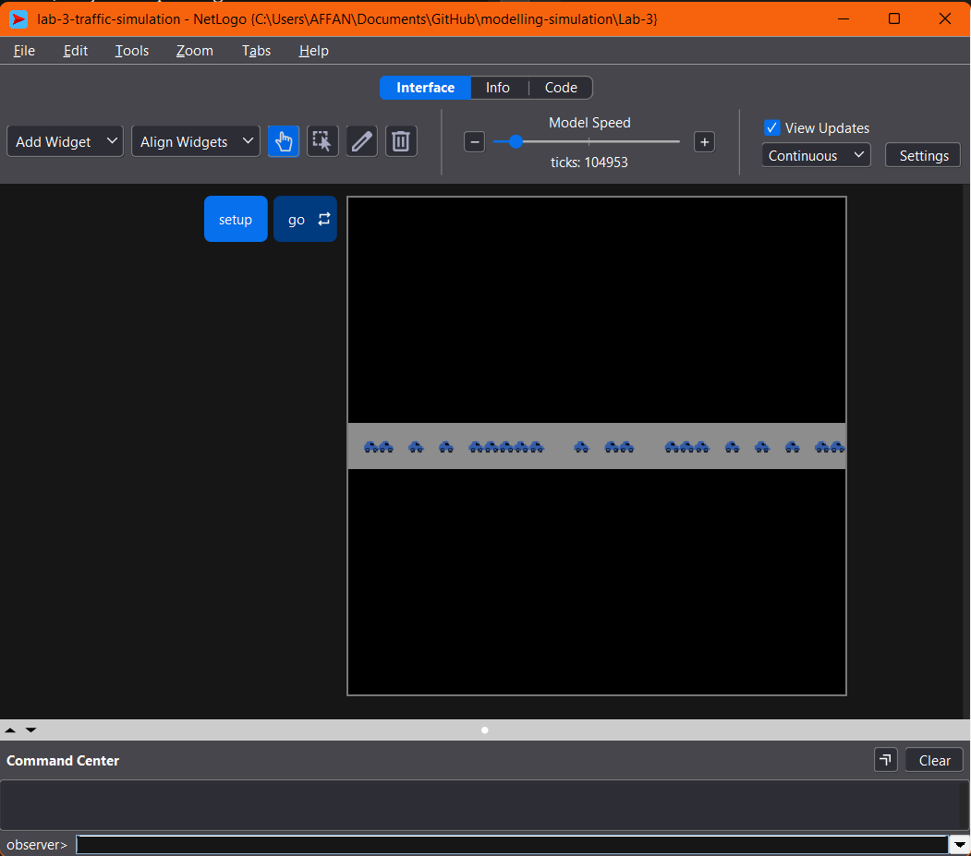

Explanation
Secondly, 20 cars were placed on a road, each facing east. Every tick, a car checks the patch ahead using turtles-on patch-ahead 1 and only moves if no car is there. The lab sheet placed cars with setxy random-xcor 0, which can put two cars on one patch, so they drive through each other. This was fixed by creating each car on its own road patch with n-of and sprout. As a result, cars queue behind each other like highway traffic.

Code
to setup
clear-all
;; draw a grey road
ask patches with [abs pycor <= 1] [ set pcolor gray ]
;; one car per patch so collision checks work
ask n-of 20 patches with [pycor = 0] [
sprout 1 [
set heading 90
set shape "car"
set color blue
]
]
reset-ticks
end

to go
ask turtles [
;; only move if the patch ahead is free
if not any? other turtles-on patch-ahead 1 [
fd 1
]
]
tick
end

Bank Queue
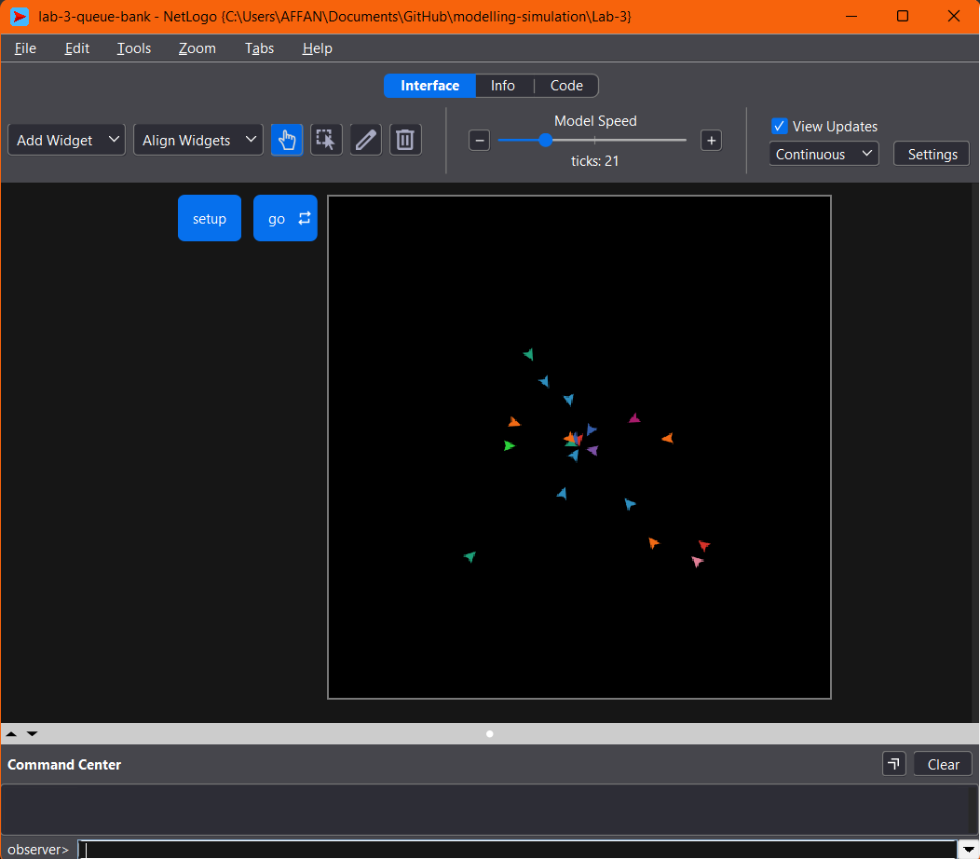

Explanation
Thirdly, 20 customers walk toward a bank counter at patch (0, 0). In the lab sheet, they only pile up around the counter, so no real queue forms. To improve it, a teller serves the closest customer one at a time, while the others stop when someone is directly ahead using in-cone 1 60, which checks a narrow area in front of the agent. As a result, a line forms and served customers leave.
Code
to setup
clear-all
create-turtles 20 [
setxy random-xcor random-ycor
]
reset-ticks
end

to go
ask turtles [
face patch 0 0
if distancexy 0 0 > 1 [
fd 0.5
]
]
tick
end

Ant Food Collection
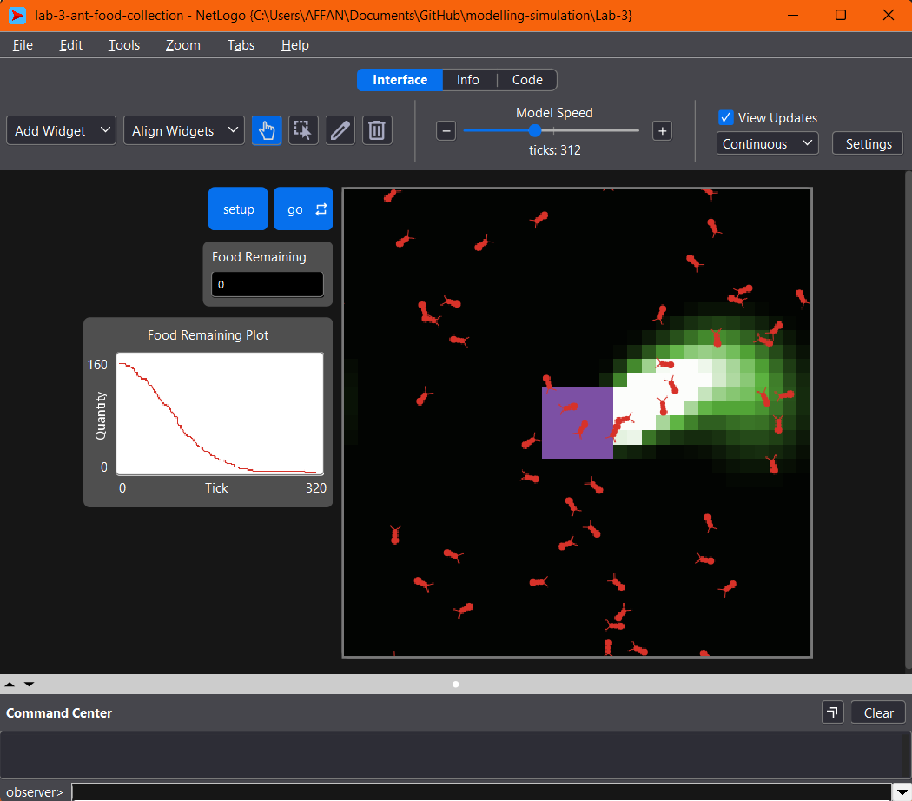

Explanation
Fourthly, 50 ants wander from a nest to find three food piles. An ant that finds food carries it home and drops pheromone, which is a chemical trail that other ants can follow. The trail spreads with diffuse and fades over time. Hence, more ants are led to the food, and the colony collects it faster than any single ant could, which is called swarm intelligence. The nest collected all pieces of food in this run.

Code
globals [food-collected]
patches-own [chemical food nest? nest-scent]
turtles-own [carrying?]

to setup
clear-all
set food-collected 0
set-default-shape turtles "bug"
create-turtles 50 [
set size 1.5
set color red
set carrying? false
]
ask patches [
set nest? (distancexy 0 0) < 3
set nest-scent 200 - distancexy 0 0 ;; stronger closer to the nest
set food 0
set chemical 0
;; three food piles
if distancexy 10 0 < 3 [ set food 2 ]
if distancexy -10 -10 < 3 [ set food 2 ]
if distancexy -10 10 < 3 [ set food 2 ]
recolor-patch
]
reset-ticks
end

to go
if sum [food] of patches = 0 and not any? turtles with [carrying?] [ stop ]
ask turtles [
ifelse carrying?
[ return-to-nest ]
[ look-for-food ]
wiggle
fd 1
]
diffuse chemical 0.5 ;; pheromone spreads
ask patches [
set chemical chemical * 0.9 ;; pheromone evaporates
recolor-patch
]
tick
end

to look-for-food ;; ant procedure
if food > 0 [
set carrying? true
set color orange + 1
set food food - 1
rt 180
stop
]
;; follow a pheromone trail if there is one
if chemical >= 0.05 and chemical < 2 [ uphill-chemical ]
end

to return-to-nest ;; ant procedure
ifelse nest? [
set carrying? false
set color red
set food-collected food-collected + 1
rt 180
] [
set chemical chemical + 60 ;; drop pheromone on the way home
uphill-nest-scent
]
end

to uphill-chemical ;; turn toward the strongest pheromone
let ahead chemical-at 0
let right-side chemical-at 45
let left-side chemical-at -45
if right-side > ahead or left-side > ahead [
ifelse right-side > left-side [ rt 45 ] [ lt 45 ]
]
end

to uphill-nest-scent ;; turn toward the nest
let ahead nest-scent-at 0
let right-side nest-scent-at 45
let left-side nest-scent-at -45
if right-side > ahead or left-side > ahead [
ifelse right-side > left-side [ rt 45 ] [ lt 45 ]
]
end

to wiggle
rt random 40
lt random 40
if not can-move? 1 [ rt 180 ]
end

to-report chemical-at [angle]
let p patch-right-and-ahead angle 1
if p = nobody [ report 0 ]
report [chemical] of p
end

to-report nest-scent-at [angle]
let p patch-right-and-ahead angle 1
if p = nobody [ report 0 ]
report [nest-scent] of p
end

to recolor-patch
ifelse nest?
[ set pcolor violet ]
[ ifelse food > 0
[ set pcolor cyan ]
[ set pcolor scale-color green chemical 0.1 5 ] ]
end

Museum Visitor Simulation
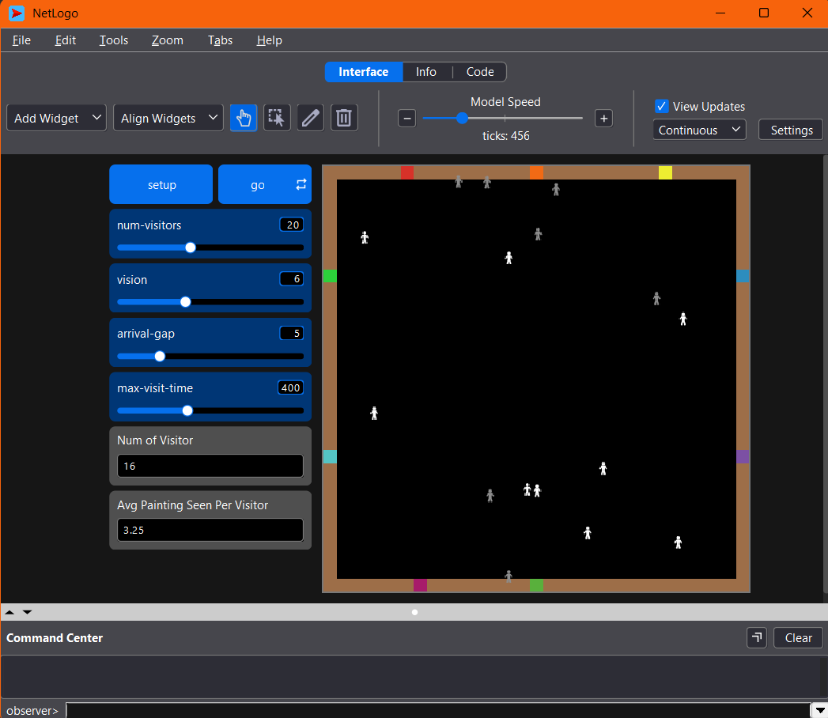

Explanation
Lastly, visitors enter a museum with eight paintings on the walls. Each visitor spots unseen paintings within a 120 degree vision cone, views the nearest one for 10 to 29 ticks, then stores it in a memory list using lput so it is never revisited. Visitors leave through the exit once all paintings are seen. This shows vision, memory and navigation working together.

Code
breed [visitors visitor]
globals [exit-patch created exited total-viewed num-paintings]
patches-own [painting-id] ;; 0 = no painting
visitors-own [memory state target view-timer entry-time]

to setup
clear-all
set-default-shape visitors "person"
ask patches [ set painting-id 0 ]
;; outer walls
ask patches with [abs pxcor = max-pxcor or abs pycor = max-pycor] [
set pcolor brown
]
;; entrance / exit in the bottom wall
set exit-patch patch 0 min-pycor
ask exit-patch [ set pcolor green ]
;; 8 paintings hung on the walls
let spots (list (patch -10 max-pycor) (patch 0 max-pycor) (patch 10 max-pycor)
(patch min-pxcor 8) (patch min-pxcor -6)
(patch max-pxcor 8) (patch max-pxcor -6)
(patch -9 min-pycor))
let colours (list red orange yellow lime cyan sky violet magenta)
set num-paintings length spots
(foreach spots (range num-paintings) [ [p i] ->
ask p [
set painting-id i + 1
set pcolor item i colours
]
])
set created 0
set exited 0
set total-viewed 0
reset-ticks
end

to go
;; a new visitor enters every arrival-gap ticks
if created < num-visitors and ticks mod arrival-gap = 0 [ add-visitor ]
ask visitors [
if state = "exploring" [ explore ]
if state = "viewing" [ view-painting ]
if state = "leaving" [ leave ]
]
if created = num-visitors and not any? visitors [ stop ]
tick
end

to add-visitor
create-visitors 1 [
move-to patch 0 (min-pycor + 1)
set heading 0
set color white
set memory []
set state "exploring"
set entry-time ticks
]
set created created + 1
end

to explore ;; visitor procedure
;; VISION + MEMORY: look for paintings in front that have not been seen yet
let unseen (patches in-cone vision 120) with [
painting-id > 0 and not member? painting-id [memory] of myself
]
ifelse any? unseen [
let p min-one-of unseen [distance myself]
face p
ifelse distance p < 1.5 [
set target [painting-id] of p
set view-timer 10 + random 20
set state "viewing"
set color yellow
] [
step
]
] [
;; NAVIGATION: nothing new in sight, wander around
rt random 41 - 20
step
]
;; leave once everything is seen, or after staying too long
if length memory = num-paintings or ticks - entry-time > max-visit-time [
set state "leaving"
set color gray
]
end

to view-painting ;; visitor procedure
set view-timer view-timer - 1
if view-timer <= 0 [
set memory lput target memory ;; remember it so it is never revisited
set state "exploring"
set color white
rt 180
]
end

to leave ;; visitor procedure
face exit-patch
ifelse distance exit-patch < 1 [
set exited exited + 1
set total-viewed total-viewed + length memory
die
] [
step
]
end

to step ;; move forward unless a wall is ahead
ifelse wall-ahead? [ rt 90 + random 90 ] [ fd 0.5 ]
end

to-report wall-ahead?
let p patch-ahead 1
report p = nobody or [pcolor = brown or painting-id > 0] of p
end

Airport Shopping Simulator
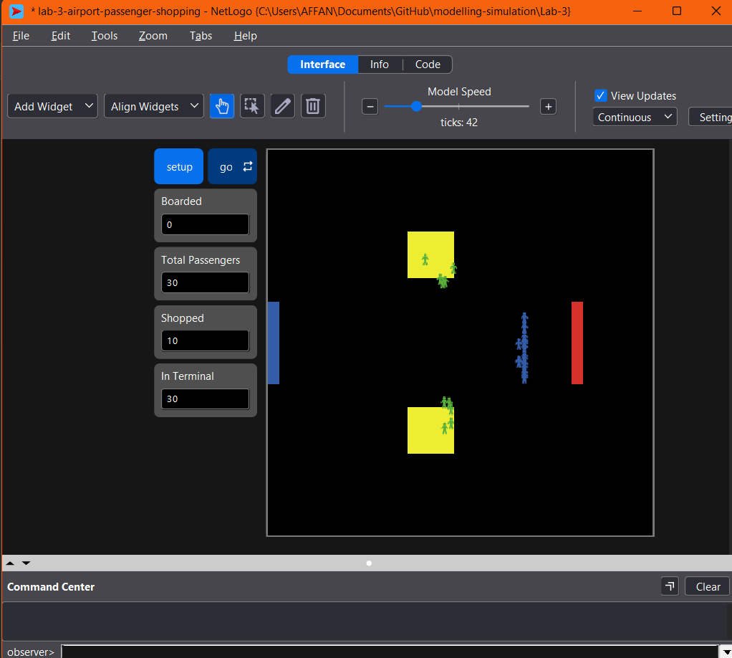

Explanation
In this demo, 30 passengers start at the blue entrance bar and walk to the red gate bar, with two yellow shops in between. Each passenger decides once, with a 20% chance, to visit a shop, stays for 10 ticks, then continues to the gate. Several sheet problems were fixed: wait freezes every agent, the shopping decision was re-rolled every tick, and the wrapped world sent passengers the wrong way. As a result, Boarded plus In Terminal always equals the total.

Code
globals [boarded gate-x]
turtles-own [shopping? shopped? boarded? target shop-time]

to setup
clear-all
set boarded 0
set gate-x 10

ask patches with [pxcor = min-pxcor and abs pycor <= 3] [ set pcolor blue ] ;; entrance bar
ask patches with [pxcor = gate-x and abs pycor <= 3] [ set pcolor red ] ;; gate bar

ask patches with [pxcor > -5 and pxcor < 0 and pycor > 5 and pycor < 10] [ set pcolor yellow ] ;; shop 1
ask patches with [pxcor > -5 and pxcor < 0 and pycor < -5 and pycor > -10] [ set pcolor yellow ] ;; shop 2

create-turtles 30 [
setxy min-pxcor (random-float 6 - 3) ;; start on the entrance bar
set shape "person"
set color blue
set shopping? (random 100 < 20) ;; decided once: 20% chance
set shopped? false
set boarded? false
set target one-of patches with [pcolor = yellow]
set shop-time 0
]
reset-ticks
end

to go
if all? turtles [boarded?] [ stop ]

ask turtles with [not boarded?] [
ifelse shopping? [
ifelse [pcolor] of patch-here = yellow [
;; inside the shop: stay 10 ticks
set shop-time shop-time + 1
if shop-time >= 10 [
set shopping? false
set shopped? true
set color green
]
] [
face target
fd 0.5
]
] [
head-to-gate
fd 0.5
]

;; reached the red gate bar: counted exactly once
if pxcor >= gate-x [
set boarded? true
set boarded boarded + 1
hide-turtle
]
]
tick
end

;; aim at the nearest point of the gate bar, always to the right (no wrap problem)
to head-to-gate
let gy max list -3 (min list 3 ycor)
set heading atan (gate-x - xcor) (gy - ycor)
end

Airport Shopping Simulator with Money
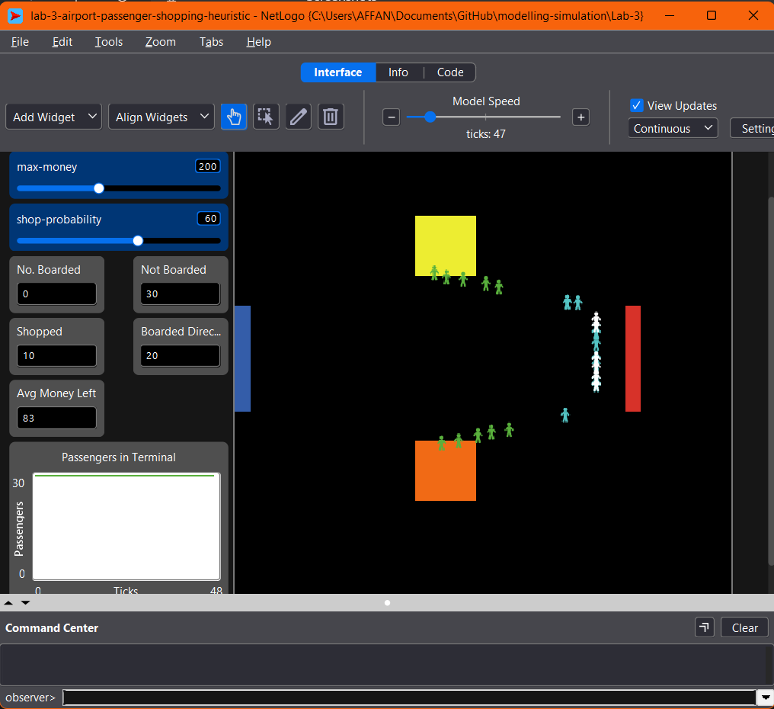

Explanation
Firstly, an airport was built with a blue entrance, a red gate and two shops in different colours. Secondly, 30 passengers were given random money and a shopped? status. Thirdly, a passenger decides once when a shop is within 10 patches, and only shoppers with at least 50 money pass a probability check, which is a heuristic, a simple rule of thumb. Lastly, shopping reduces money, and monitors and a plot track the results. The bonus tasks added shopper types, a shop capacity of 5 and a final call.

Code
breed [shoppers shopper] ;; Task 7
breed [non-shoppers non-shopper]

globals [
boarded
gate-x
min-budget ;; Task 4: minimum money needed to shop
percent-shoppers ;; Task 7: % of passengers who are the shopper type
shop-capacity ;; Task 8: max passengers inside one shop
departure-time ;; Task 9: tick when the flight leaves
final-call ;; Task 9: stop shopping this many ticks before departure
]

patches-own [shop-id] ;; 0 = not a shop, 1 or 2 = shop number

turtles-own [
money
shopped?
boarded?
route ;; "undecided", "direct" or "shop"
state ;; "to-gate", "to-shop" or "in-shop"
target-shop
shop-timer
]

;; ---------------- SETUP ----------------
to setup
clear-all
set boarded 0
set gate-x 10

;; settings you can change to test the bonus tasks
set min-budget 50
set percent-shoppers 70
set shop-capacity 5
set departure-time 150
set final-call 30

;; Task 1: environment
ask patches [ set shop-id 0 ]
ask patches with [pxcor = min-pxcor and abs pycor <= 3] [ set pcolor blue ] ;; entrance
ask patches with [pxcor = gate-x and abs pycor <= 3] [ set pcolor red ] ;; gate
ask patches with [pxcor > -5 and pxcor < 0 and pycor > 5 and pycor < 10] [
set pcolor yellow
set shop-id 1
]
ask patches with [pxcor > -5 and pxcor < 0 and pycor < -5 and pycor > -10] [
set pcolor orange
set shop-id 2
]

;; Task 2 and Task 7: passengers
create-turtles 30 [
ifelse random 100 < percent-shoppers
[ set breed shoppers set color cyan ]
[ set breed non-shoppers set color white ]
set shape "person"
setxy min-pxcor (random-float 6 - 3) ;; start at the entrance
set money random (max-money + 1) ;; random amount of money
set shopped? false ;; shopping status
set boarded? false
set route "undecided"
set state "to-gate"
set target-shop 0
set shop-timer 0
]
reset-ticks
end

;; ---------------- GO ----------------
to go
if all? turtles [boarded?] [ stop ]
if ticks >= departure-time [ stop ] ;; the flight has left

ask turtles with [not boarded?] [
if final-call? [ abandon-shopping ] ;; Task 9
if state = "to-gate" [ consider-shopping ] ;; Task 4

ifelse state = "to-gate"
[ move-to-gate ] ;; Task 3
[ ifelse state = "to-shop" [ move-to-shop ] [ do-shopping ] ] ;; Task 5
]
tick
end

;; Task 3: walk to the red gate bar
to move-to-gate
let gy max list -3 (min list 3 ycor)
set heading atan (gate-x - xcor) (gy - ycor)
fd 0.5
if pxcor >= gate-x [
set boarded? true
set boarded boarded + 1
hide-turtle
]
end

;; Task 4: decide ONCE, when a shop first comes into view
to consider-shopping
if route != "undecided" [ stop ]
if final-call? [ set route "direct" stop ]
if not any? ((patches in-radius 10) with [shop-id > 0]) [ stop ]
ifelse (breed = shoppers) and (money >= min-budget) and (random 100 < shop-probability)
[ choose-shop ]
[ set route "direct" ]
end

;; Task 8: pick a shop that is not crowded, otherwise go to the gate
to choose-shop
let free-shops filter [ s -> not crowded? s ] [1 2]
ifelse empty? free-shops [
set route "direct"
set state "to-gate"
] [
let best min-one-of patches with [member? shop-id free-shops] [distance myself]
set target-shop [shop-id] of best
set route "shop"
set state "to-shop"
]
end

to-report crowded? [s]
report count turtles with [state = "in-shop" and target-shop = s] >= shop-capacity
end

;; Task 5: go to the shop, stay a while, then pay
to move-to-shop
if crowded? target-shop [ choose-shop ] ;; shop filled up on the way
if state = "to-shop" [
let my-shop target-shop ;; FIX: copy it before using it inside "with [...]"
face min-one-of patches with [shop-id = my-shop] [distance myself]
fd 0.5
if [shop-id] of patch-here = my-shop [
set state "in-shop"
set shop-timer 10 + random 11
]
]
end

to do-shopping
set shop-timer shop-timer - 1
if shop-timer <= 0 [
let spend min (list money (10 + random 41))
set money money - spend ;; reduce money
set shopped? true ;; record that shopping happened
set color green
set state "to-gate" ;; resume moving to the gate
]
end

;; Task 9: departure timer
to-report final-call?
report ticks >= departure-time - final-call
end

to abandon-shopping
if state = "to-shop" or state = "in-shop" [
set state "to-gate"
set color violet
]
end



